Requirements Specification

Simple TimeSheet Management

**Tolgahan KARABUDAK 16050111042**

**Rıdvan EREL 18050151010**

**Kaan ABBASOĞLU 16050111030**

**Ahmet Fatih ÇOPUR 17050111020**

**Table of Contents**

|  |  |  |  |
| --- | --- | --- | --- |
| 1. Introduction ............................................................................................................................................... | | | 1 |
| 1.1 | Purpose ................................................................................................................................................ | | 1 |
| 1.2 | Scope ................................................................................................................................................... | | 1 |
| 1.3 | Definitions, acronyms, and abbreviations ........................................................................................... | | 1 |
| 1.4 | References ........................................................................................................................................... | | 2 |
| 2. Overall description .................................................................................................................................... | | | 4 |
| 2.1 | Product perspective ............................................................................................................................. | | 4 |
| 2.2 | Product functions ................................................................................................................................ | | 4 |
| 2.3 | User characteristics ............................................................................................................................. | | 5 |
| 2.4 | Constraints .......................................................................................................................................... | | 5 |
| 2.5 | Assumptions and dependencies .......................................................................................................... | | 5 |
| 2.6 | Apportioning of requirements ............................................................................................................. | | 6 |
| 3. Specific requirements ................................................................................................................................ | | | 7 |
| 3.1.1 | | User interfaces ............................................................................................................................. | 7 |
| 3.1.2 | | Hardware interfaces ..................................................................................................................... | 8 |
| 3.1.3 | | Software interfaces ....................................................................................................................... | 8 |
| 3.1.4 | | Communications interfaces .......................................................................................................... | 9 |
| 3.2 | Functional requirements ...................................................................................................................... | | 9 |
| 3.2.1 | | User Class 1 - The User ............................................................................................................... | 9 |
| 3.2.2 | | User Class 2 - Restaurant Owner ............................................................................................... | 14 |
| 3.2.3 | | User Class 3 - Administrator ...................................................................................................... | 18 |
| 3.3 | Performance requirements ................................................................................................................ | | 21 |
| 3.4 | Design constraints ............................................................................................................................. | | 23 |
| 3.5 | Software system attributes ................................................................................................................ | | 23 |

i

**1. Introduction**

The Timesheet System is a system designed to be able to manage the timesheets produced by the clock in and out personal working system used currently on personal. It will support functionality to approve timesheets, allow administrators to overwrite users activities.

**1.1 Purpose**

The purpose of this SRS document is to document the requirements of the Timesheet System. By creating a timesheets, it supports the user to use his/her time effectively and to work in a planned way.

**1.2 Scope**

Anyone who wants to work with a plan. For example, developers, students, employees.

**1.3 Product Scope**

These are our features to have our application scope;

* Login Page
* CRUD system
  + Create System
  + Read System
  + Update System
  + Delete System
* Search system
  + Date Search
    - Start / End
  + Name Search
* MASTER DETAIL PAGE ??

**2. Overall description**

In this section, we will provide you with information on how the entire system works. You will see how the system works, what resources it is based on, what functions it contains and who it covers and how it covers.

**2.1 Product perspective**

This system will run through a web application with database side. The web application will be used to find, view and manage information as a whole. The Web application will need to access database with security for login.

This web application has a data-centric structure, it will need a place to store data. The database will be used for this. The Web application will use the database to add, delete, read or modify data. All database communication will be dockerized.

**2.2 Product functions**

It is a website that will make a Timesheet manage system. This website is intended for personal use. People can use this app to manage their time. One of the main purposes of the application is to make it easy for all kinds of users to use it. In this way, we wanted to make it useful not only for expert users, but also for the average person.

**2.3 User characteristics**

For now we only have one user. But we are planning to bring an update in the future.

User Type -1

Manager class is associated with employee. Candidates can receive their applications from human resources or create a job posting. The candidate does not see the manager's actions. He only sees the results. If he wishes, he can watch the interview. In the application, the security and privilege level is the highest class.

- Can list and organize his/her timesheet.

- Can examine calander.

- Can add task for timesheet.

- Can delete task for timesheet.

- Can edit task for timesheet.

- Can read task for timesheet.

- Can search in his/her tasks from timesheet.

**2.5 Constraints**

A personal computer with an internet connection.

**2.6 Assumptions and dependencies**

A browser with JavaScript support is also required.

**3. Specific requirements**

This section contains all of the functional and quality requirements of the system. It gives a detailed description of the system and all its features.

**3.1 External interface Requirements**

This section offers a thorough explanation of the system's inputs and outputs.

It also includes a description of the hardware, software, and communication interfaces,

as well as rudimentary user interface prototypes.

**3.1.1 User interfaces**

Since we will add the login page later, we wanted to skip this part for now. On the left side of the homepage are the main modules that make up the timesheet. We planned to be able to handle operations such as listing, sorting and search from the right side of the homepage. We planned to create drop-down lists for the search page. You can also review the UI part below.

BURADA EKLENECEK KISIMLAR BAŞLIYOR KAANIN MOCK UI KISIMLARI

**Database Diagram**

In general, our database design will be on these tables, but we wanted to design it open to changes with the newly added login page. If the login page is added, we can create a new table where we can process the data we have taken with PK's.

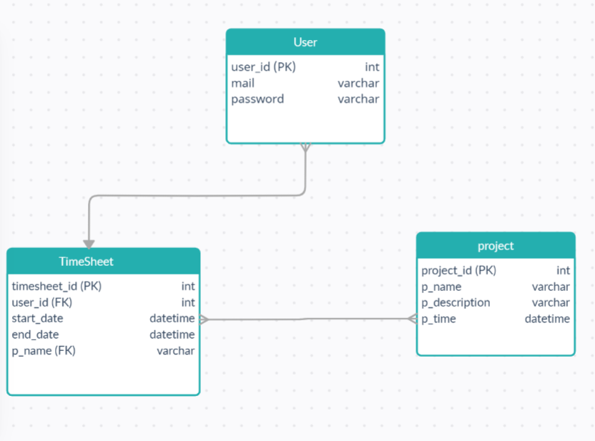

**3.2 Functional requirements**

is section includes the requirements that specify all the fundamental actions of the software system.